**LETS GROW MORE INTERNSHIP**

**2.PREDICTION USING DECISION TREE ALGORITHM**

**INTRODUCTION:**

This is my first project using R programming . The project makes use of the Prediction of database using decision tree algorithm. Let's get to it!

**Load dataset:**

> library(rpart)

> library(rpart.plot)

> data = read.csv("C:/Users/Bharat Kaushik/Desktop/Predictive Analysis.csv")

> tree = rpart(Height ~ gender+Weight,data)

> a = data.frame(gender=c("Male"),Weight=c(85))

> result = predict(tree,a)

> print(result)

1

180.4375

**Plot:**

> tree = rpart(Height ~ gender+Weight,data)

> rpart.plot(tree)

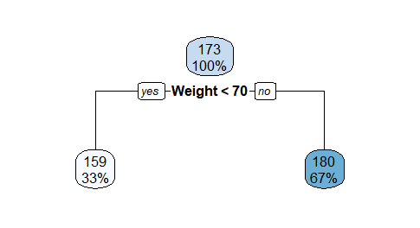

> tree= rpart(gender~Height+Weight,data)

> tree= rpart(gender~Height+Weight,data)

> rpart.plot(tree)

> a=data.frame(Height=c( 190),Weight=c(85))

> result=predict(tree,a)

> print(result)

Female Male

[1,] 0.1666667 0.8333333

> tree= rpart(gender~Height+Weight,data)

> rpart.plot(tree)

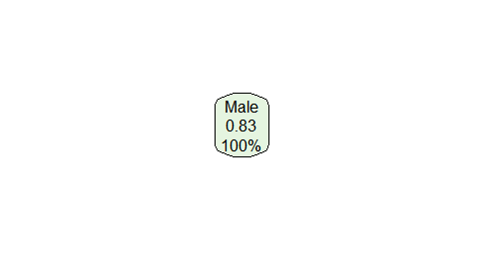

**Summary of the dataset:**

> summary(tree)

Call:

rpart(formula = gender ~ Height + Weight, data = data)

n= 24

CP nsplit rel error xerror xstd

1 0 0 1 0 0

Node number 1: 24 observations

predicted class=Male expected loss=0.1666667 P(node) =1

class counts: 4 20

probabilities: 0.167 0.833